Digital Nurture 5.0 - Java FSE React

Week 1 - Module 1: Design Patterns and Principles
Name : Sarthak kumar
Email : rphoenix432@gmail.com

Exercise 1: Implementing the Singleton Pattern

1. Objective
The objective of this exercise is to implement the Singleton Design Pattern in Java by creating a logging utility class that allows only one object to be created throughout the application lifecycle.

2. Scenario
A logging utility is required in an application. Since logging should remain consistent across the entire application, only one instance of the logging class should exist. To achieve this, the Singleton Pattern is used.

3. Project Details
Project Name: SingletonPatternExample
Programming Language: Java
Design Pattern Used: Singleton Pattern
Module: Week 1 - Design Patterns and Principles

4. Project Structure

Screenshot 1: Project Structure


5. Logger.java
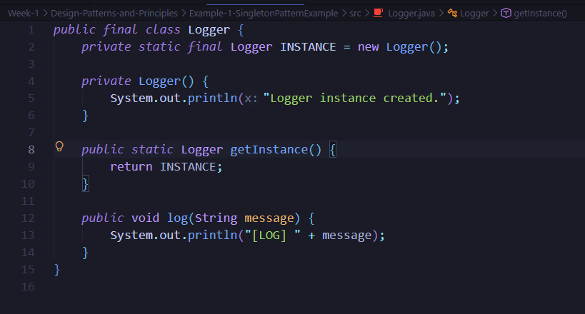

6. SingletonPatternTest.java
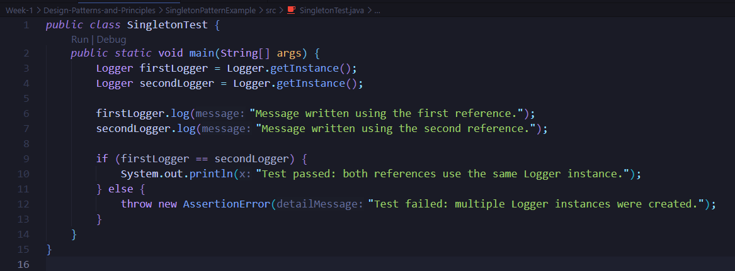

7. Output

8. Conclusion
The Singleton Pattern was successfully implemented in Java.
The Logger class allows only one instance to be created and reused across the application. This ensures consistent logging throughout the application lifecycle.

